SOFTWARE PROJECT MAMNGEMENT PLAN

Document Revision #: 1

Date of Issue: July 3rd, 2020

Project Manager: Temi Owoeye

# Introduction

* 1. Project Overview

“How To” is a website that houses organized video instructions to lead users into excellency with their desired talent or skill. This website will allow people to set up free tutorials online for a wide range of skills. From learning an instrument to learning how to make DIY home furniture, How To will have a wide range of tutorials for people to learn whatever they desire to learn. How To will be organized in levels to make sure that there are no gaps in foundational understandings. It will have features that will encourage learners to remain consistent. It will also have features that will allow learners to communicate with teachers in real-time when they have questions.

However, the benefit of “How To” is that it relieves the stress of trying to find lessons and put them in order based on your level of understanding of the skill you trying to learn. How To will allow learners evaluate themselves to know what level they are on and place them in a learning path based on the results. Also, learners will have the luxury of having real-time communication with teachers, there will also be an option to learn skills as a group as well.

* 1. Project Deliverables

1. Approved Topic Proposal 7.4.2020
2. Design Review Meeting 7.4.2020
3. Tool Selection Review Meeting 7.10.2020
4. SPMP Plan with Software Process 7.12.2020
5. Change Management 7.15.2020
6. Gannt Chart Schedule 7.20.2020
7. WBS 7.25.2020
8. Milestone Review
9. System Test Plan
10. Presentation 8.1.2020 28th!
    1. Evolution of the SPMP

I anticipate that some dates will need to be adjusted once processes start being implemented.

I have adjusted the tools that will be used for the project. Instead of using GoDaddy for web hosting, I have decided to go with SiteGround.

* 1. Reference Materials

SPMP Outline/Guideline 🡪 <https://www.academia.edu/28118705/Example_of_Software_Project_Management_Plan_SPMP_>

SPMP Example Reference 🡪 <https://code4sac.github.io/benefisher/assets/documents/SPMP.pdf>

Organizational Chart 🡪 <https://en.wikipedia.org/wiki/Software_company>

* 1. Definitions and Acronyms

“HT” 🡪 How To

# Project Organization

2.1 Process Model

I have chosen to use the Agile model. This allows testing in all stages of development. 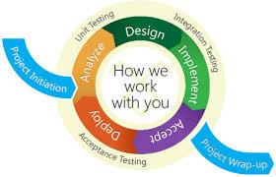

2.2 Organizational Structure

I will be fulfilling all the roles for this project.

Roles

* Project Plan
* Requirements Specification
* Analysis
* Architecture Spec
* Component/Object Specification
* Test Plan
* Final Deliverable

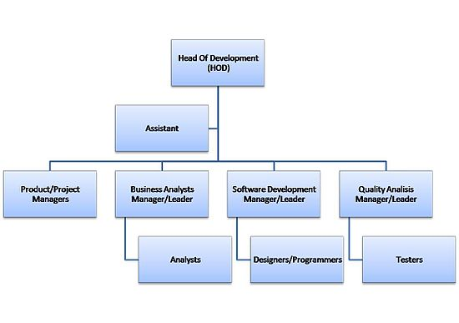

This picture above is an example of the organizational structure that I will be following. However, I will be fulfilling each role because this is an individual project.

2.3Organizational Interfaces

I will be using the following vendors:

* SiteGround – web hosting service
* Namecheap – domain name registrar for domain name only
* Wordpress.org – content management system where I will host my website
* GitHub – version control
* Plugins through wordpress and siteground will also be used as I find need for them

2.4 Project Responsibilities

I am responsible for each roles of the project.

# Managerial Process

3.1 Management Objectives and Priorities

The management objective is to make sure the product is delivered in high quality and sensible time. In order to do so, the plans must be followed and adjusted immediately when a fault is found. This way, progress can be up to date while maintaining the product’s quality.

3.2 Assumptions, Dependencies and Constraints

External events the project depends on and constraints under which the project is to be conducted include:

* Final Product Due: 7.28.2020
* Product Presentation: 7.28.2020
* Budget: $50 for external software used to develop “HT”

**Prices so far:**

* Namecheap domain name: FREE
* SiteGround webhosting: $24
* WordPress: FREE

3.3 Risk Management

“The goal of risk management is to identify and mitigate potential sources of expense or delay. Some risks are common to every project phase, and some risks are closely associated with a particular project phase. Risks for this project have been classified accordingly”

1. Size of the Project

If during development, I notice that the size of the project is too big with the given timeline, I will then reduce the scope of the project and focus on a specific genre of tutorials rather than a wide range of options. I will also reduce number of user functionalities.

1. Insufficient Funds for Product Security

I will then alter the software in a way that ensures that the users have basic security protocols on their end, I will also limit the user capabilities to avoid abuse of the product. I will also enforce RECaptcha and Secure Cert to make sure browsers are secure.

1. Falling behind schedule

Accept the truth rather than ignoring it. Rearrange the priorities of development

1. Poor Design

Could lead to security issues or unavailability of the product.

3.4 Staffing Plan

This is an individual Project.

3.5 Monitoring and Controlling Mechanisms

Reporting will be in the form of documentation. Since I am the only one on this project, I will reference this document in order to make changes. I will make these reports for each cycle of development that I go through (AGILE process).

# Technical Process

4.1 Methods, Tools and Techniques

Tools that will be used to create this product include WordPress (PHP), Visual Studio Code for code development, GitHub for versioning, and SiteGround for webhosting. In combination with some extensions and plug-ins that I will find as I progress in development of the website.

4.2 Software Documentation

I will be using GitHub for the documentation of HowTo. For each component that I develop in each stage of the AGILE process, I will document what that component was made for and how it can be used. This way, it will be documented in depth.

4.3 Project Support Functions

* Quality Assurance Plan

This section describes policies and procedures that will be used to meet QA program objectives. In order to ensure the quality of this product the following procedures will be conducted periodically

* Frequent testing of the product
* Inspection of code design
* Penetration testing to find vulnerabilities
* Configuration Management Plan
* Verification and Validation Plan

# Description of Work Packages

Work Breakdown Structure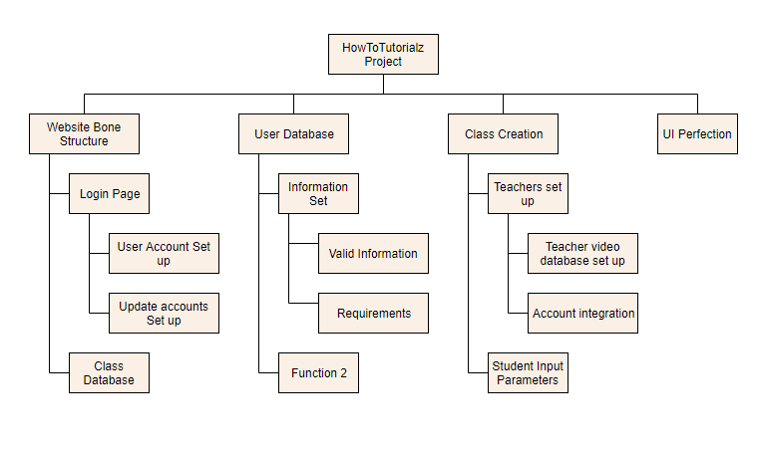

Dependencies between Tasks

# Functional & Non-Functional Requirements

Functional

1. Support Donations to Teachers
   1. Each teacher should have a page or button for students that want to make donations. This button should be on the teachers “about you” page
   2. A student would click ‘Donate” and redirected to a payment page
2. A main webpage for first time visitors (main log in page), returning students, and returning users
   1. From here, users will be prompted to either make an account, continue as a guest, or login to their account
   2. Then they will be redirected to the main page
3. Allow users to search up their desired skill to learn
   1. Users will type in the search bar the genre of the skill they would like to learn
   2. Results will be based on the user’s skill search
4. Test Users Skill level
   1. For each new course that a student wants to begin, they will be evaluated using a test made by the teacher of that course, in order to allow correct placement in the level of a course

Non-Functional

Teachers

1. Create an account for approval by HowTo team
2. Create, edit, and delete a teaching playlist
3. Add, edit, and delete teaching video content
4. Link banking information for payment
5. Update account profile with pictures of themselves, and a bio of themselves and the amount of years they have in the subject that they are teaching
6. Moderate comments under their video content
7. Have a private chat room with students
8. Act as students for other courses without having teacher privileges for those courses
9. Delete account

Students

1. Create and account, no need for approval
2. Take a “placement” test for the skill that they’d like to learn
3. Enroll in a course based on placement test
4. Interact with teacher in a chat room
5. Comment on teachers’ videos
6. Upload content on student account page to show off their progress to all other HowTo students and teachers
7. Join a group of learners
8. Make donations to the teachers
9. Delete account